Skills for a Changing World: Basic Computer Terminology

Insert the correct computer term in the grey box.

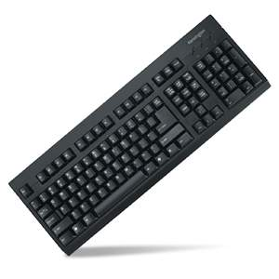 | An input hardware device used to insert data into the computer system.
 | An object in the Windows Operating System (OS) from where you can access all the installed programs
  
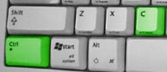 | A keyboard shortcut used to copy data to the computer's memory in any program.
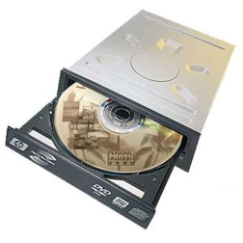 | Input device used to read compact disks
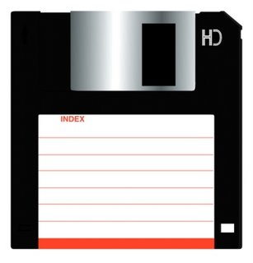 | A 3.5'' disk that can hold 1.4 MB of information and be used again and again
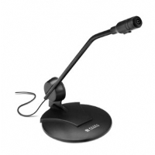 | An input device used to capture sound for use on the computer
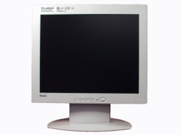 | Output hardware device used to display text and images
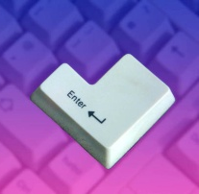 | A key used to execute a command or move to the next line in a word processor software package
  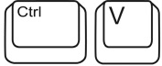 | A print out of a computer generated document
 | A keyboard shortcut used to paste data from the computer's memory into any program.
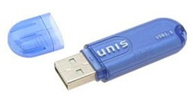 | A storage device that has no moving parts and is popularly used as a USB stick
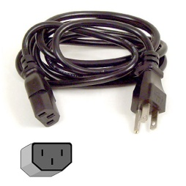 | Cord needed to provide electricity to the computer
 | Button used to activate the computer from rest
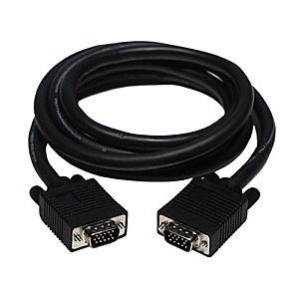 | Cord needed to connect the screen to the computer.
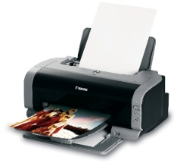 | Output device used to create 'hardcopies'.
 | A keyboard shortcut used to cut data from a program and place it in the computer's memory.
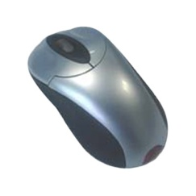 | A device used to point to positions on the screen.
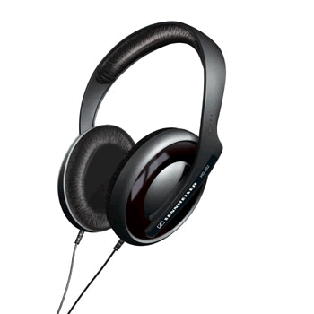 | A device used to output sound
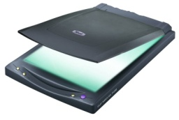 | An input device that makes digital copies of paper based documents
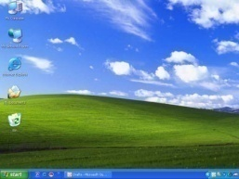 | The working environment of a program. The way a program is designed to encourage use.
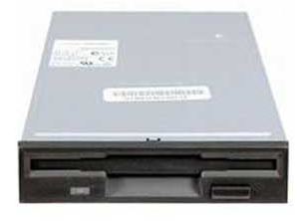 | The device used to read 3.5" floppy disks
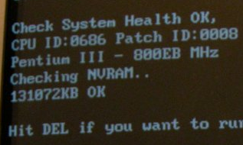 | A sequence the computer goes through when you turn it on to load the operating system and ready itself for use.
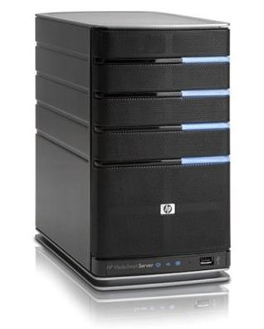 | The main computer that coordinates all computers on a network to work together and share resources.
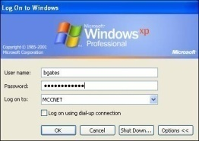 | The action of identifying yourself on the network whenever you use a networked computer.
Skills for a Changing World, 2009 (CC: BY)

